matlab scripts and functions
PREPARED BY
Tyler Long
In partial fulfillment of the requirements for
ECET 4610
PREPARED BY:
APPROVED BY:
September 28, 2008
SOUTHERN POLYTECHNIC STATE UNIVERSITY
Introduction:

The purpose of this experiment was to further introduce the capabilities of Matlab and to explore its ability to execute user written programs. This lab also advances the programmer’s ability to troubleshoot and become resourceful when writing/debugging a Matlab program.

There were two types of programs introduced: Scripts and Functions. The manner in which each executes and the purpose for each are the main differences. Each will also hold the ‘.m’ extension to its respective file name.

A script file is executed by typing its filename within the command window excluding the ‘.m’ extension. The user is then prompted to enter the inputs defined by the written program. Once the program has finished, the variables defined within the program are then reflected to the workspace window within Matlab. These variables are considered global variables.

A function is executed by typing in its function name within the command window followed by the input variables set by the program. A function will not update variables within the workspace window since variables within a function are considered local variables.
Quiz 1:

Lowpass Code:
%This program will be called Lowpass
%This program plots the amplitude and phase response of a low-pass RC filter.
%Date Programmer Your major
%=== ========== =====================
%9-15-08 Tyler Long EET

%ampl amplitude response
C= input('Enter a value for the capacitance: '); %Capacitance in Farads
R= input('Enter a value for the resistance: '); %Resistance in Ohms

% phase phase response
% gain Vo/Vi=1/(1+j2pifRC)
f= input('Enter the range of values for the frequency: '); %Frequency range

gain=1./(1+j*2*pi*f*R*C);
ampl= abs(gain);

%phase= angle(gain);
phase=angle(gain);

%create plots
subplot(3,1,1);
loglog(f,ampl);
title('Amplitude response - Tyler Long');
xlabel('Frequency in [Hz]');
ylabel('Vo/Vi Ratio');
grid on;
subplot(3,1,3);
semilogx(f,phase);
title('Phase response - Tyler Long');
xlabel('Frequency in [Hz]');
ylabel('out-inp phase in [rad]'); grid on;

Lowpass Plots:
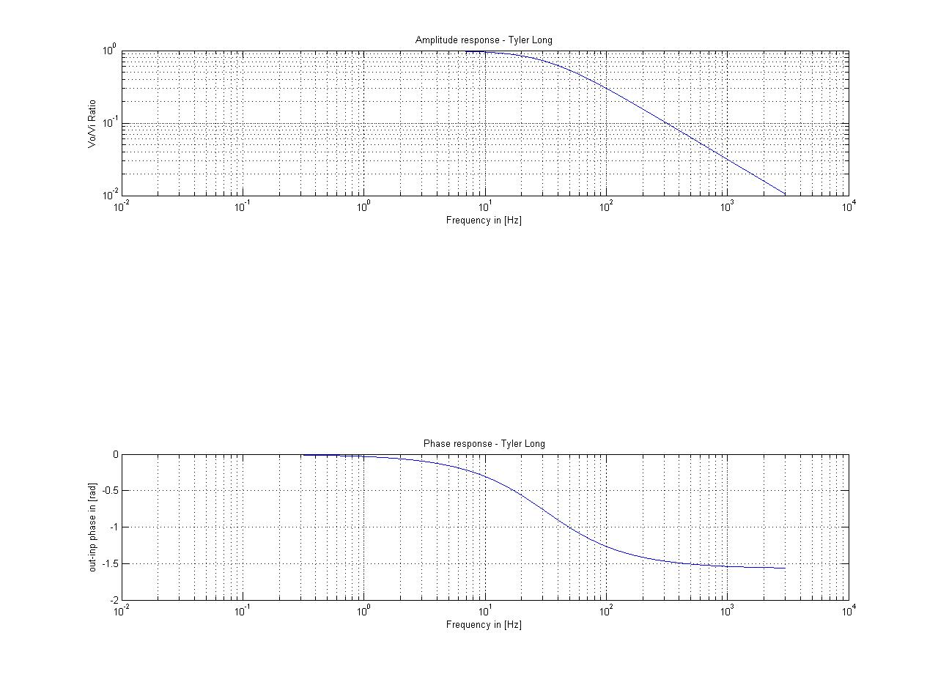
Figure 1: Lowpass

Response Code:
%Function freqresp = resp(R,C,f)
%This program will be called program no 2.
%It is function that plots the amplitude and phase response of a low-pass
%RC filter
%date programmer description of change
%=== ========== =====================
%9-15-08 Tyler Long Murphy
%ampl amplitude response
C= input('Enter a value for the capacitance : '); %Capacitance in Farads
R= input('Enter a value for the resistance : '); %Resistance in Ohms
% phase phase response
% gain Vo/Vi=1/(1+j2pifRC).
f= input('Enter the range of values for the frequency: '); %Frequency range
gain=1./(1+j*2*pi*f*R*C);
ampl = abs(gain);
phase=angle(gain);
%create plots
subplot(3,1,1);
loglog(f,ampl);
title('Amplitude response - Tyler Long');
xlabel('Frequency in [Hz]');
ylabel('Vo/Vi Ratio');
grid on;
subplot(3,1,3);
semilogx(f,phase);
title('Phase response - Tyler Long');
xlabel('Frequency in [Hz]');
ylabel('out-inp phase in [rad]'); grid on;

Response Plots:

This program was converted from a function to a script type program. The output plot of the response program will be the same as the lowpass program. See Figure 1 for plot example.
Quiz 2:

Trajectory Code:
function trajectory = Quiz_2(x0,v0,t,t1)
%This program will be called Trajectory
%It is function that calculates the distance and plots the distance
%Date Programmer Description of change
%=== ========== =====================
%9-22-08 Tyler Long Murphy

%Parameters

x=x0+v0*t+.5*-9.8*t.^2;

%create plots

plot(t,x);
title('Trajectory of Ball - Tyler Long');
xlabel('Time [sec]');
ylabel('Height [m]');
grid on;

x1=x0+v0*t1+.5*-9.8*t1.^2;

['The height at time ' num2str(t1) ' seconds is ' num2str(x1) ' meters.']

Trajectory Plot:
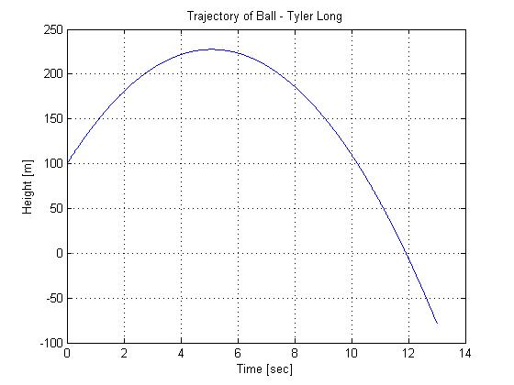
Figure 2: Trajectory
ans =

The height at time 10 seconds is 110 meters.
Quiz 3:

Microphone Code:
%This program will be called microphone gain
%This program plots the gain of a microphone
%Date Programmer Your major
%=== ========== =====================
%9-22-08 Tyler Long EET

%Input Parameters
g= input('Enter a value for the microphone constant: '); %Mic variable
angle1= input('Enter a starting angle degrees: '); %Angle in degrees
angle2= input('Enter an ending angle degrees: '); %Angle in degrees

rad1=angle1*(pi/180);
rad2=angle2*(pi/180);

if angle1<=angle2
theta=rad1:.01:rad2;
else
theta=rad2:.01:rad1;
end

GAIN=2*g*(1+cos(theta));

polar(theta,GAIN)
title('Microphone Gain - Tyler Long');
grid on;

Microphone Plot:
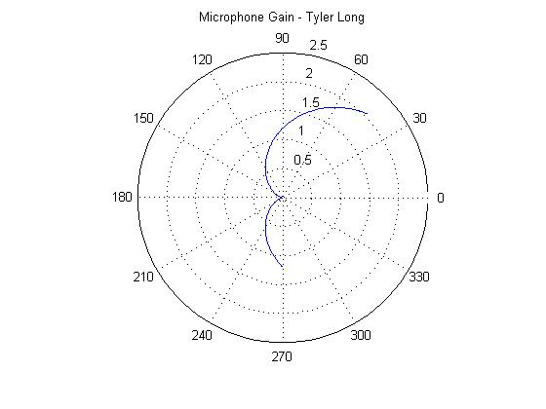
Figure 3: Microphone Gain
Quiz 4:

Average Test Code:
%This program will be called average
%This program calculates the average test grade for a course
%Date Programmer Your major
%=== ========== =====================
%9-24-08 Tyler Long EET

%Input Parameters
t1= input('Enter a grade for Test#1: '); %Test 1 grade
t2= input('Enter a grade for Test#2: '); %Test 2 grade
t3= input('Enter a grade for Test#3: '); %Test 3 grade

%Average test grade calculation
avg=(t1+t2+t3)/3;

%Letter grade determination

if avg >= 90
'Your grade is: A'
elseif avg >= 80
'Your grade is: B'
elseif avg >= 70
'Your grade is: C'
elseif avg >= 60
'Your grade is: D'
else
'Your grade is: F'
end

Average Test Output:

ans =

Your grade is: C
Quiz 5:

Satellite Orbit Code:
%This program will be called Orbit
%It is function that plots the orbit of a satellite
%Date Programmer Description of change
%=== ========== =====================
%9-24-08 Tyler Long Murphy

%Input Parameters
e1= input('Enter a value for epsilon 1: '); %epsilon 1
e2= input('Enter a value for epsilon 2: '); %epsilon 2
e3= input('Enter a value for epsilon 3: '); %epsilon 3

%Constants
p=1000; %parameter specifying the size of the orbit
theta=0:.001:2*pi;

%Array ordering
earray=[e1,e2,e3];
emax= max(earray);
emed=median(earray);
emin=min(earray);

%Epsilon max value entered
r1=p./(1-emax*cos(theta));

%Epsilon median value entered
r2=p./(1-emed*cos(theta));

%Epsilon min value entered
r3=p./(1-emin*cos(theta));

%Plot
polar(theta,r1);
title('Satellite Orbit - Tyler Long');
grid on;
hold;
polar(theta,r2,'r');
polar(theta,r3,'g');

%Min-Max for e1
re1=p./(1-e1*cos(theta));
re1max=max(re1);
re1min=min(re1);
['Epsilon 1 max= ' num2str(re1max) ' and Epsilon 1 min= ' num2str(re1min)]

%Min-Max for e2
re2=p./(1-e2*cos(theta));
re2max=max(re2);
re2min=min(re2);
['Epsilon 2 max= ' num2str(re2max) ' and Epsilon 2 min= ' num2str(re2min)]

%Min-Max for e3
re3=p./(1-e3*cos(theta));
re3max=max(re3);
re3min=min(re3);
['Epsilon 3 max= ' num2str(re3max) ' and Epsilon 3 min= ' num2str(re3min)]
Satellite Orbit Plots:
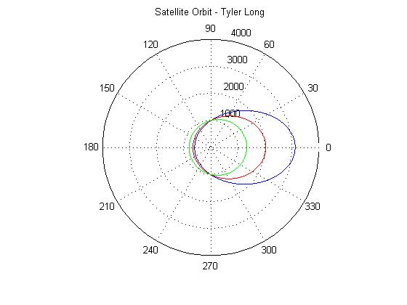
Figure 4: Satellite Orbit

ans =

Epsilon 1 max= 3125 and Epsilon 1 min= 595.2381

ans =

Epsilon 2 max= 1333.3333 and Epsilon 2 min= 800

ans =

Epsilon 3 max= 2040.8163 and Epsilon 3 min= 662.2517
Conclusion:

One of the key notes I learned was the proper use of the semicolon in order to reduce the amount of clutter printed to the command window. This increased the usability of the program so that all inputs and outputs could be seen in the command window without having to scroll up and down.

The use of the “if” statement was integral to the functionality of both quiz three and four. Each of the two programs required their variables to be handled in a certain order for the program to function properly. The “if” statement in quiz 3 removed the chance the user would enter in the values for the variables in the improper order. The “if” statement in quiz 4 made sure that the correct grade was chosen by starting with the highest grade first.

In order to ensure that in quiz five the order of epsilon variables entered did not matter, an array was setup from the user entered epsilon values. From this array, new variables were defined by using the min, median, and max commands. This allowed the program to cherry pick the correct epsilon to plot in order of greatest to least which in turn ensures the plot will scale properly.

